**Building your Care Partner Toolbox**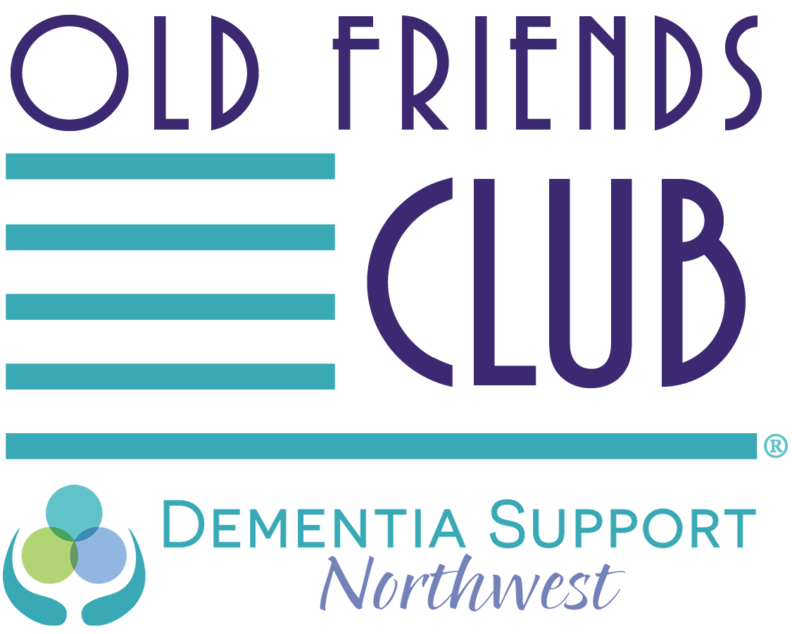

*A website scavenger hunt!*

Visit **www.oldfriendsclub.org/mainresources** to explore helpful care partner resources and use this document to take notes! We hope this “toolbox” will be helpful on your caregiving journey.

|  |  |
| --- | --- |
| **Find one affirmation that resonates with you that you can say to yourself every day:** |  |
| **Find the Area Agencies on Aging tab - visit the website for the agency in your county and get familiar with the services they offer.** | *Name of AAA and website:* |
| **Support groups will help you feel less alone! Check out the support group tab and find a group you’d like to join.** | *Support Group Name, date/time held, and contact information of facilitator:* |
| **Education will help you understand what’s happening and what’s to come. Review the education tab and find one education option that you’re interested in attending.** |  |
| **Explore local events and activities! Reduce social isolation by being around others. Use this tab to get familiar with places to look for upcoming events and activities. See one you like? Make a note of it in the column to the right!** |  |
| **Respite/Relax Old Friends Club offers respite options! Check out the stress/relaxation tab to learn about additional ways to manage stress and relax. Are there any ideas that are helpful for you?** |  |
| **Legal/Financial: Use this tab to review legal/financial resources that are helpful to be aware of and prepare for. Take notes to the right:** |  |
| **Explore other resources and record any that would be helpful to refer back to!** |  |